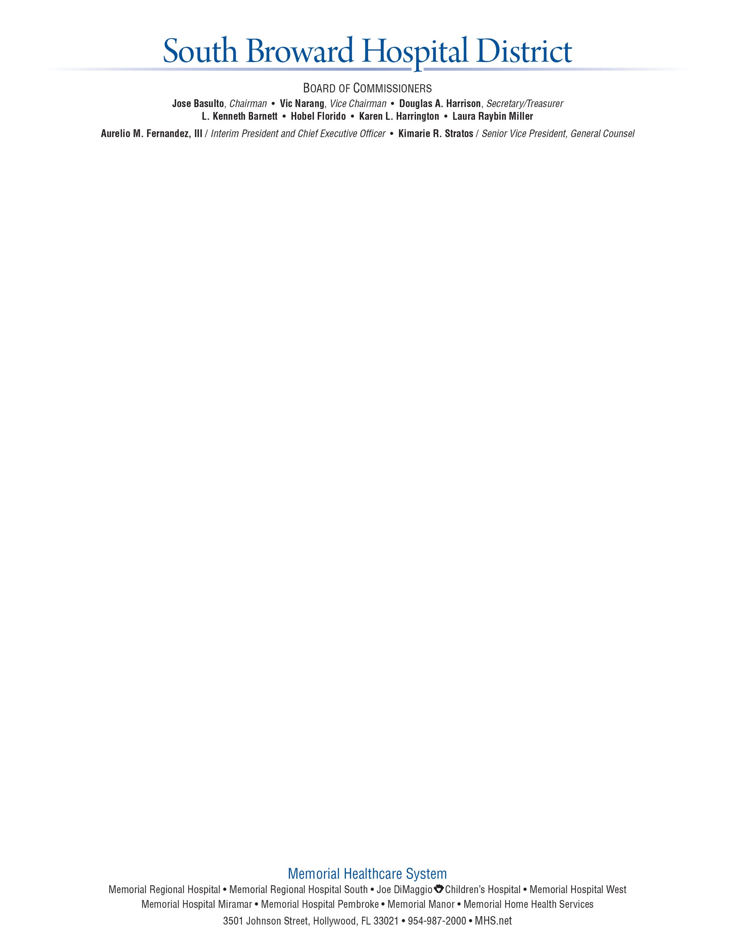

April 6, 2016

To the Memorial Healthcare System employees and medical staff:

The Board of Commissioners has conducted a series of public interviews with our selected executive search firm, Korn Ferry, with the goal of finding the next President and CEO of the South Broward Hospital District dba Memorial Healthcare System (MHS). After a series of candidate interviews, the Board of Commissioners selected Aurelio M. Fernandez, III, FACHE, during Tuesday’s CEO Search Committee Meeting.

Mr. Fernandez has close to 40 years of experience in healthcare and brings exceptional knowledge in the acute care setting and hospital operations in both private and public management. Throughout his career, Mr. Fernandez has worked in numerous leadership positions in healthcare and part of his career has been also centered on finances.

Mr. Fernandez has been with the Memorial Healthcare System for the past nine years, serving first as CEO of Memorial Hospital Miramar before being promoted to Executive Vice President and Chief Operating Officer of Memorial Healthcare System in 2012. Effective March 1, 2016, he was named interim President and CEO.

Mr. Fernandez earned a Bachelor’s degree in Business Administration and a Master’s degree in Health Services Administration from Florida International University. He currently serves on the Board of the Florida Hospital Association and is a Fellow of the American College of Healthcare Executives.

Congratulations Mr. Fernandez. We look forward to working with you, the employees and physicians and the entire Memorial community for the benefit of the patients and families we serve.

Sincerely,

Board of Commissioners